**Mythical Cook Team Bonding Evening**

**Potluck**

**Activities Done**

**Kahoot Quizzes**

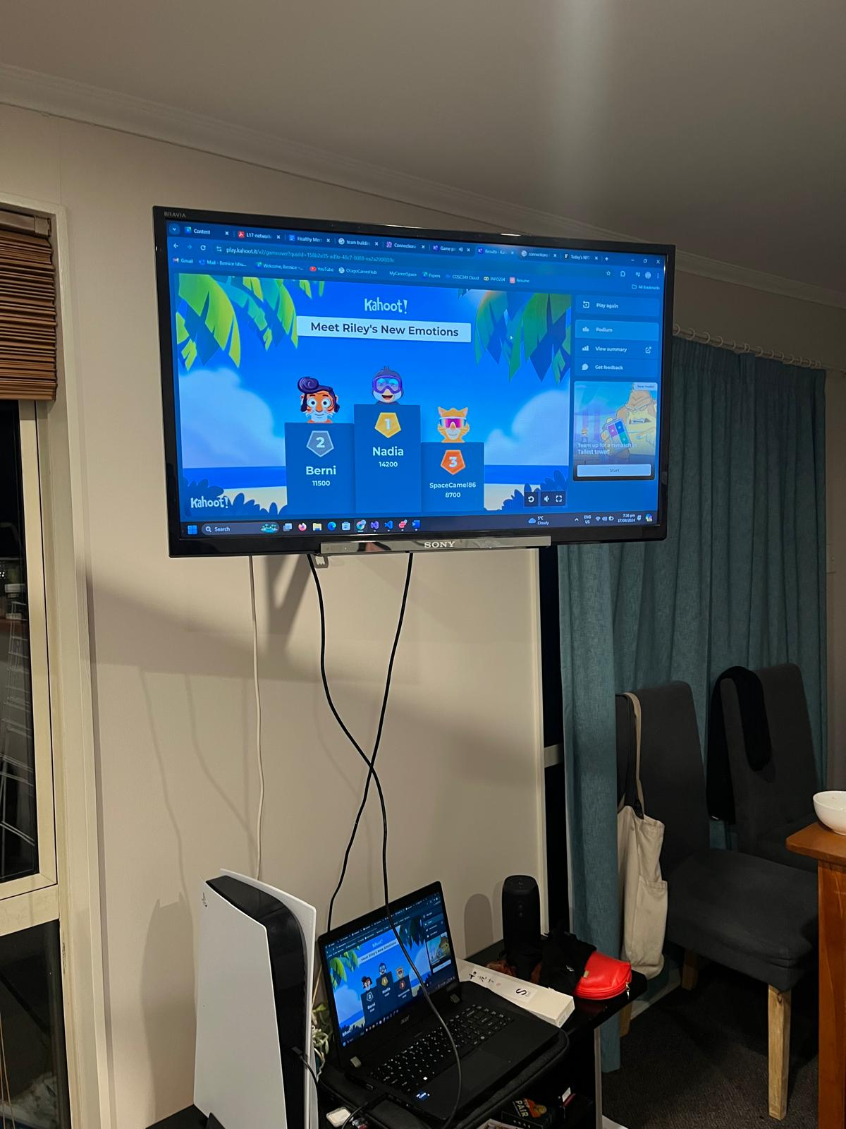

**Break the Ice with The Four Quadrants Activity**

Sometimes pictures are better than words when it comes to helping a team get to know one another. Creative games like this one can also be especially effective at helping introverts or distanced teams share with the group.

Start by handing out sheets of paper and inviting each participant to draw a 2×2 grid and pose four questions to the group. Each team member draws their answer in one of the grid squares and once the time limit is up, invite the group to share. If you’re looking for a fun game that encourages creative thinking while being visual and memorable, look no further!

1. Two truths, one lie

Team size: 3+ people

Time: 2–3 minutes per person

How to play: Ask everyone in the group to come up with two facts about themselves and one lie. The more memorable the facts (e.g., I went skydiving in Costa Rica) and the more believable the lies (e.g., I have two dogs), the more fun the game will be! Then, ask each team member to present their three statements and have the group vote on which one they think is the lie.

4. One word exercise

Team size: 3+ people

Time: 5–10 minutes

How to play: Pick a phrase related to the meeting topic and ask everyone to write down one word that comes to mind on a post-it. Then, gather these words on a whiteboard or put them in a presentation.